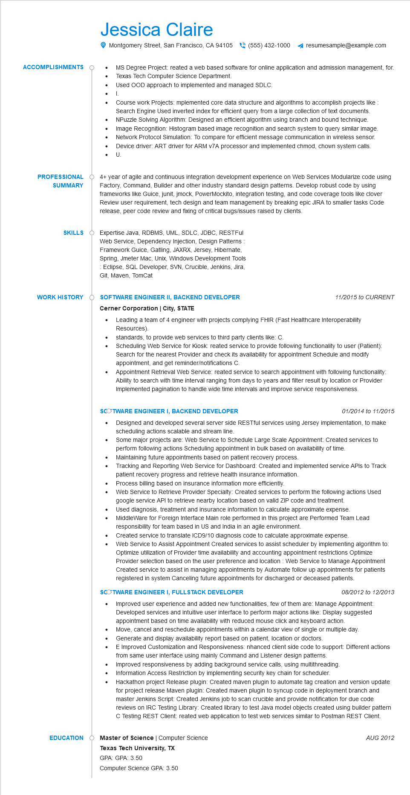
ACCOMPLISHMENTS
•
Jessica Claire
•
.
•
•
•
•
Montgomery Street, San Francisco, CA 94105(555) 432-1000 ◄ resumesample@example.com
MS Degree Project: reated a web based software for online application and admission management, for. Texas Tech Computer Science Department.
I.
Used OOD approach to implemented and managed SDLC.
Course work Projects: mplemented core data structure and algorithms to accomplish projects like Search Engine Used inverted index for efficient query from a large collection of text documents. NPuzzle Solving Algorithm: Designed an efficient algorithm using branch and bound technique. Image Recognition: Histogram based image recognition and search system to query similar image. Network Protocol Simulation: To compare for efficient message communication in wireless sensor. Device driver: ART driver for ARM v7A processor and implemented chmod, chown system calls. U
PROFESSIONAL SUMMARY
4+ year of agile and continuous integration development experience on Web Services Modularize code using Factory, Command, Builder and other industry standard design patterns. Develop robust code by using frameworks like Guice, junit, jmock, PowerMockito, integration testing, and code coverage tools like clover Review user requirement, tech design and team management by breaking epic JIRA to smaller tasks Code release, peer code review and fixing of critical bugs/issues raised by clients.
SKILLS Expertise Java, RDBMS, UML, SDLC, JDBC, RESTFul Web Service, Dependency Injection, Design Patterns: Framework Guice, Gatling, JAXRX, Jersey, Hibernate, Spring, Jmeter Mac, Unix, Windows Development Tools Eclipse, SQL Developer, SVN, Crucible, Jenkins, Jira, Git, Maven, TomCat
WORK HISTORY SOFTWARE ENGINEER II, BACKEND DEVELOPER
Cerner Corporation | City, STATE
•
11/2015 to CURRENT
Leading a team of 4 engineer with projects complying FHIR (Fast Healthcare Interoperability Resources).
standards, to provide web services to third party clients like: C.
Scheduling Web Service for Kiosk: reated service to provide following functionality to user (Patient): Search for the nearest Provider and check its availability for appointment Schedule and modify appointment, and get reminder/notifications C.
Appointment Retrieval Web Service: reated service to search appointment with following functionality: Ability to search with time interval ranging from days to years and filter result by location or Provider Implemented pagination to handle wide time intervals and improve service responsiveness.
EDUCATION
SCOTWARE ENGINEER I, BACKEND DEVELOPER
•
•
01/2014 to 11/2015
Designed and developed several server side RESTful services using Jersey implementation, to make scheduling actions scalable and stream line.
Some major projects are: Web Service to Schedule Large Scale Appointment: Created services to perform following actions Scheduling appointment in bulk based on availability of time.
Maintaining future appointments based on patient recovery process.
Tracking and Reporting Web Service for Dashboard: Created and implemented service APIs to Track patient recovery progress and retrieve health insurance information.
Process billing based on insurance information more efficiently.
Web Service to Retrieve Provider Specialty: Created services to perform the following actions Used
google service API to retrieve nearby location based on valid ZIP code and treatment.
Used diagnosis, treatment and insurance information to calculate approximate expense. MiddleWare for Foreign Interface Main role performed in this project are Performed Team Lead responsibility for team based in US and India in an agile environment.
Created service to translate ICD9/10 diagnosis code to calculate approximate expense.
Web Service to Assist Appointment Created services to assist scheduler by implementing algorithm to: Optimize utilization of Provider time availability and accounting appointment restrictions Optimize Provider selection based on the user preference and location: Web Service to Manage Appointment Created service to assist in managing appointments by Automate follow up appointments for patients registered in system Canceling future appointments for discharged or deceased patients.
SCOTWARE ENGINEER I, FULLSTACK DEVELOPER
08/2012 to 12/2013
• Improved user experience and added new functionalities, few of them are: Manage Appointment: Developed services and intuitive user interface to perform major actions like: Display suggested appointment based on time availability with reduced mouse click and keyboard action. Move, cancel and reschedule appointments within a calendar view of single or multiple day.
•
•
Generate and display availability report based on patient, location or doctors.
E Improved Customization and Responsiveness: nhanced client side code to support: Different actions
from same user interface using mainly Command and Listener design patterns.
Improved responsiveness by adding background service calls, using multithreading.
Information Access Restriction by implementing security key chain for scheduler.
Hackathon project Release plugin: Created maven plugin to automate tag creation and version update for project release Maven plugin: Created maven plugin to syncup code in deployment branch and master Jenkins Script: Created Jenkins job to scan crucible and provide notification for due code reviews on IRC Testing Library: Created library to test Java model objects created using builder pattern C Testing REST Client: reated web application to test web services similar to Postman REST Client.
Master of Science | Computer Science
Texas Tech University, TX
GPA: GPA: 3.50
AUG 2012
Computer Science GPA: 3.50

